VISHAAL SV 192412349 ECA0502 EMF

EXP 5
Determination and plotting of Electric potential difference between any two points in free space medium separated by a distance R.
PROGRAM:
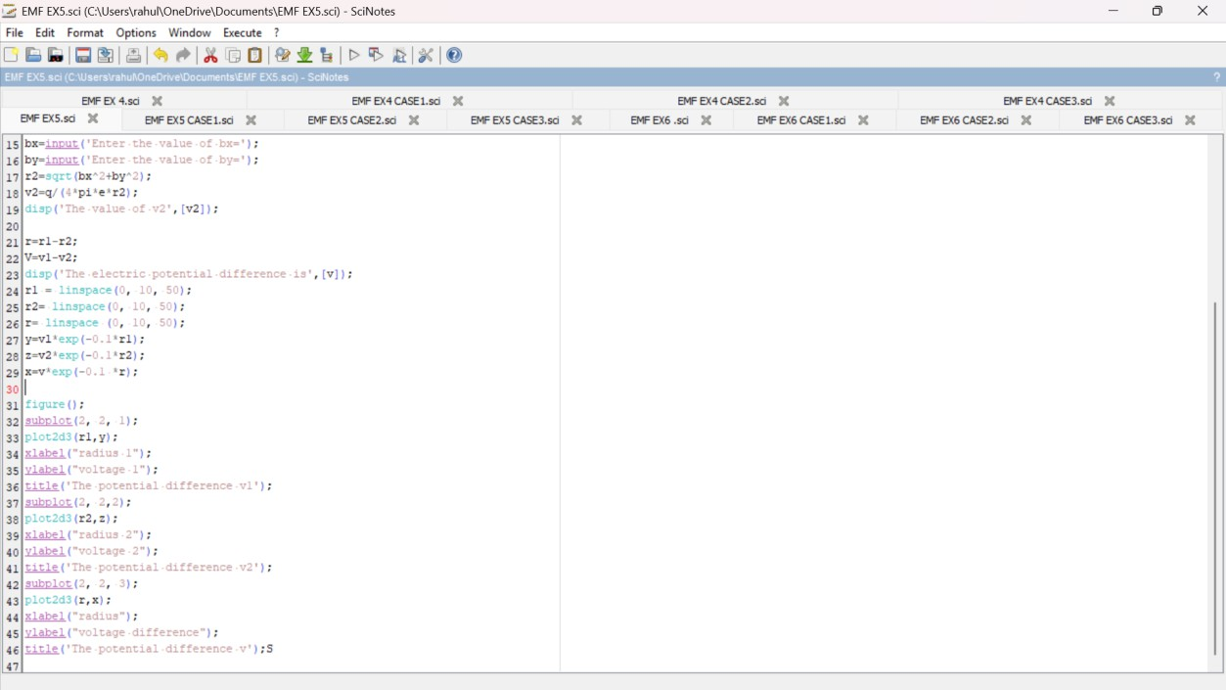

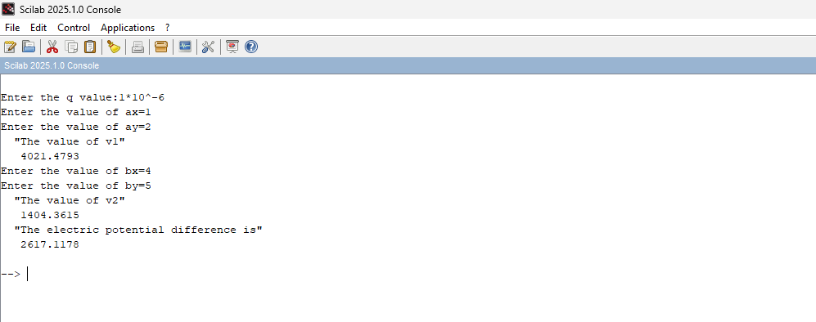OUTPUT:
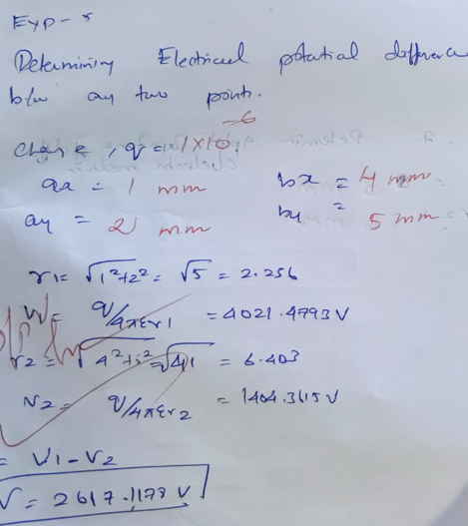

CASE 1:
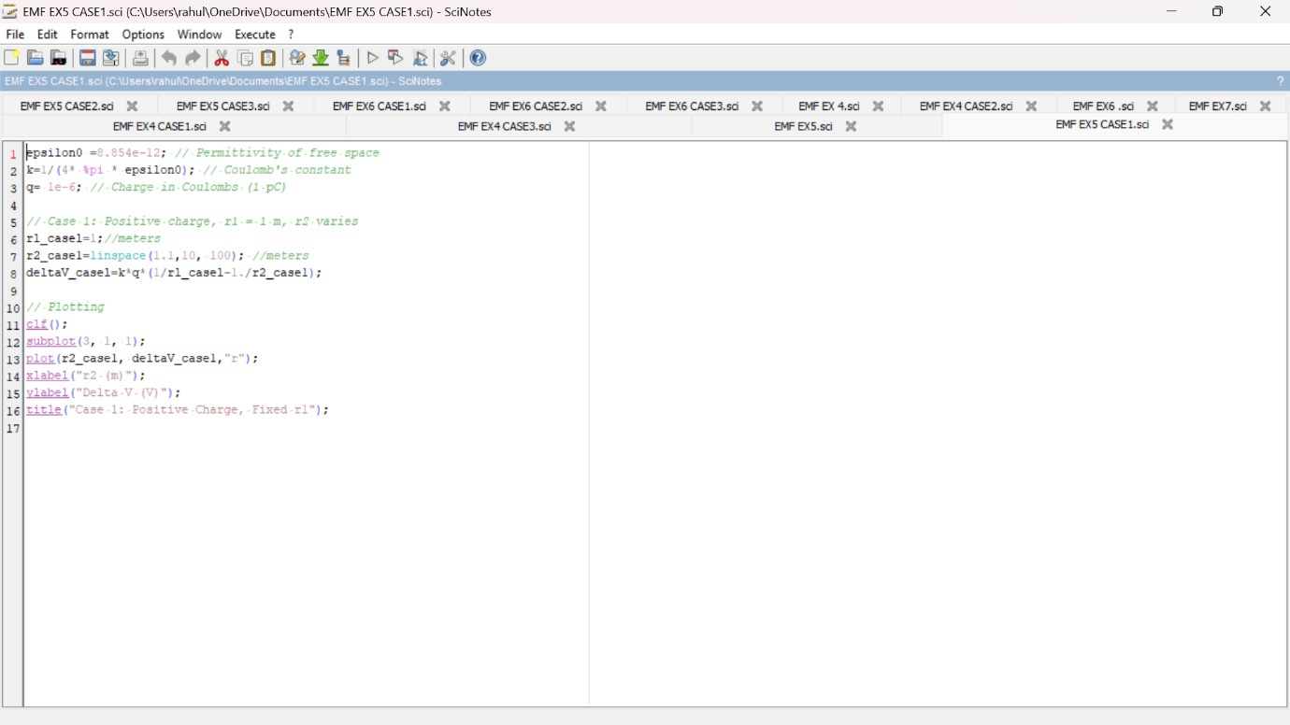
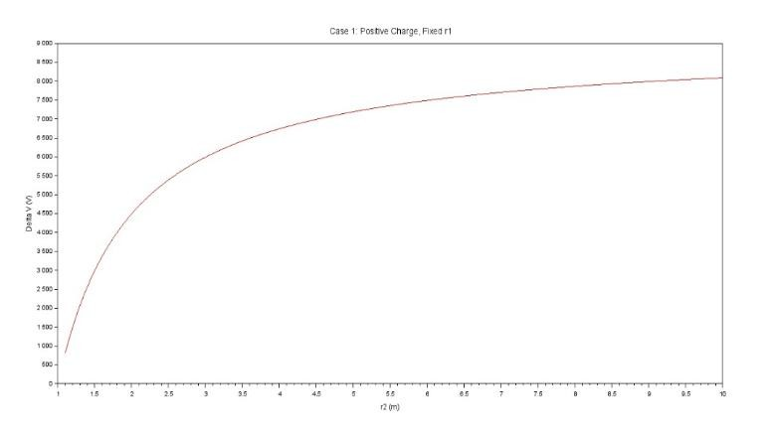
PROGRAM AND OUTPUT:

CASE 2:
PROGRAM AND OUTPUT:
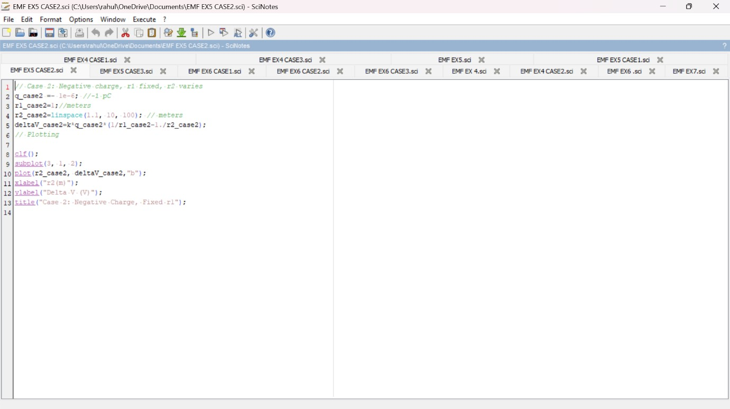
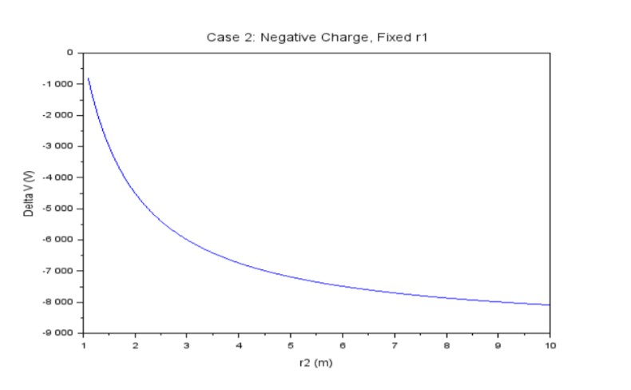

CASE 3:
PROGRAM AND OUTPUT
